**ICE 4/25 – Due on or before Sunday 4/28, 2019 –**

**Objectives:** Single Dimensional Array

Your name:

|  |
| --- |
| **Important instructions:**   * *All programs must include comments at the top of your program: your name,* the class name (CSIT 575)*, program name and* ***the program description (purpose of the program).*** * *Copy and paste your* ***program code*** *and* ***output*** *in Part B of each program. Note: Use snipping tool to* ***snip the output****.* * *Once it is done, save and submit this word file via Canvas.* |

**1. AnalyzeNumbers.cpp**

Write a program that calculates the sum, average, positive and negative numbers of a size-5 array entered by users.

**Sample run:**

You can enter 5 integer numbers.

Enter a new number: 5

Enter a new number: -16

Enter a new number: 25

Enter a new number: -3

Enter a new number: 30

Sum is 41

Average is 8.2

Number of negative: 2

Number of positive: 3

**Part B: Copy and paste your program (source) code and the outputs after this line**

**+++++++++++++++++++++++++++++++++++++++++++++++++**

**2. LargerThanN.cpp**

Write a program contains a random array holding 25 integers between 1 and 100. The program takes an integer from a user in this range, the program will display how many of the numbers are larger than the user-entered value.

Given function prototype and constant array SIZE

int countLarger(int[], int, int);

const int SIZE = 25;

**Sample run:**

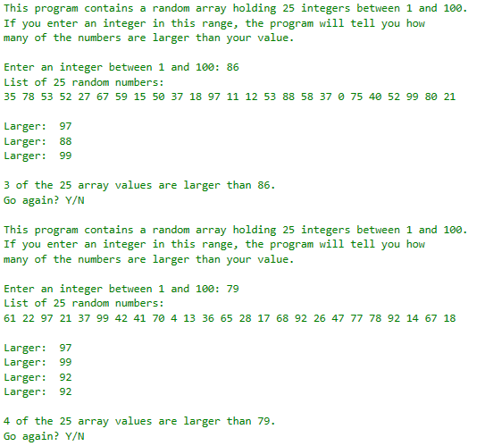

**Part B: Copy and paste your program (source) code and the outputs after this line**

**+++++++++++++++++++++++++++++++++++++++++++++++++**